Git Challenges Task
1: Resolve Merge Conflicts
- Create a merge conflict intentionally (two users editing the same line).
- Resolve the conflict and push the changes.

1. Create a merge conflict intentionally — ✅ Completed
You:
- Created conflict.txt.
- Created conflict-branch.
- Changed the same line differently in task10 and conflict-branch.
- Ran git merge conflict-branch.
- Git produced:
CONFLICT (content): Merge conflict in conflict.txt
2. Resolve the conflict and push — ✅ Completed
You:
- Edited conflict.txt.
- Removed the conflict markers.
- Added the resolved file.
- Committed the resolution.
- Successfully pushed to GitHub:
c9fad14..062ecb9 task10 -> task10

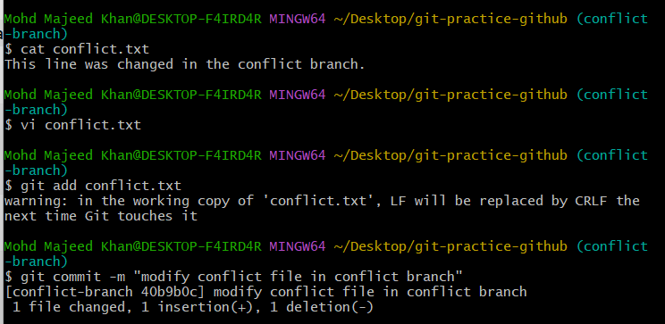
Next step — change the same line on task10
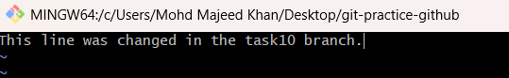
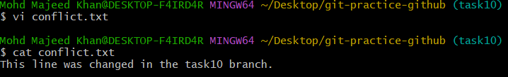
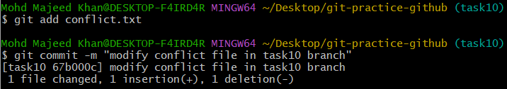
Next step — create the merge conflict
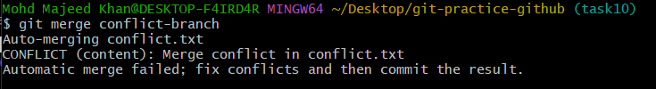
Now we need to resolve the conflict by keeping one final line.
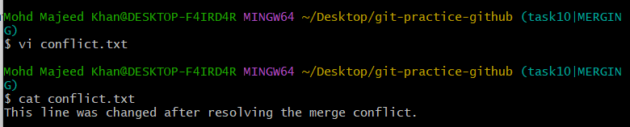
Step 1 — Stage the resolved file
git add conflict.txt
Step 2 — Complete the merge
git commit -m "Resolve merge conflict"
Step 3 — Push the resolved merge to GitHub
git push origin task10 (task10 is branch name)
Step 4 — Verify
Git status

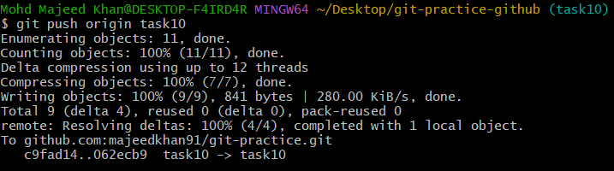
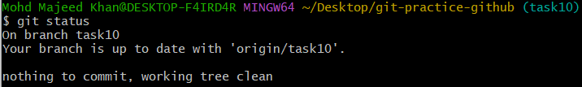
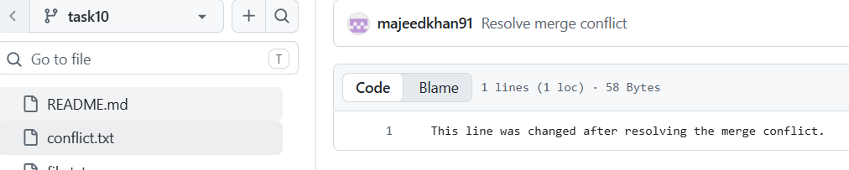

2: Recover Deleted Branch
  - Delete a local branch and then recover it using the reflog.
The goal is to practice:
- Create a branch.
- Make a commit on it.
- Delete the local branch.
- Use git reflog to find the lost commit.
- Recover the deleted branch from that commit.

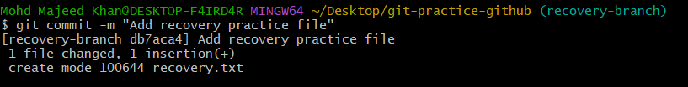
Delete recovery-branch: git branch -D recovery-branch
The important commit ID is: db7aca4
Now we will recover the deleted branch using git reflog.
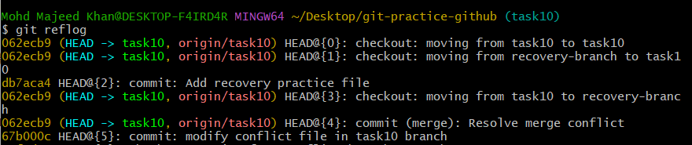
Recover the deleted branch -git branch* recovery-branch
git checkout -b recovery-branch db7aca4 (ab71ca4 is commit ID)

3: Undo Wrong Push
- Push a wrong commit to GitHub, then undo it without losing history.
The goal is to:
- Make an intentionally wrong change.
- Commit it.
- Push it to GitHub.
- Use git revert to undo that commit.
- Push the revert commit to GitHub.
- Confirm that the wrong change is removed without deleting the history.

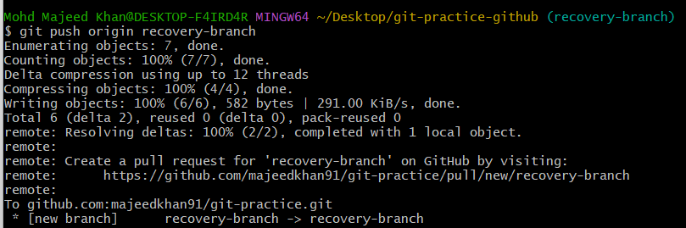
Step 2 — Revert the wrong commit
Your wrong commit ID was: 271b40c Add wrong change
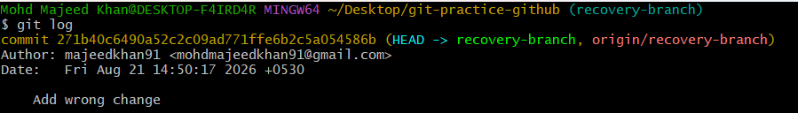
git revert commit id git revert 271b40c
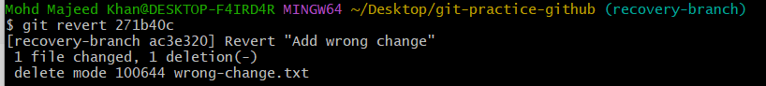
Check the history: git log --oneline -3
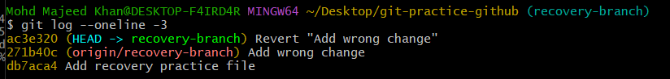
git push origin recovery-branch
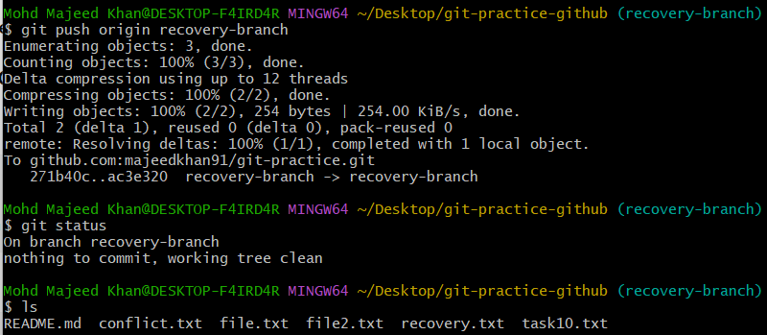
4: Amend a Commit
- Make a commit, then add a missing file to it using git commit --amend.
The goal is to:
- Make a commit with one file.
- Realize another file was missed.
- Add the missing file.
- Use git commit --amend to add it to the previous commit.
Amend a Commit: vi filenameedit file “add message” and save :wq!
Cat filename then git add filename final command git commit -m “add message”
Modify the same file: as second line
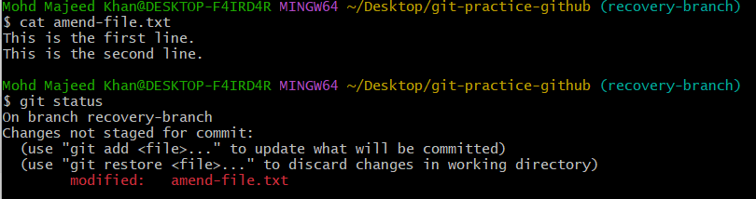
So, the file has been modified but not committed yet. This is exactly what we want for the amend exercise.
git commit --amend means modify the most recent commit instead of creating a new commit.
Next step — stage the modified file
git add amend-file.txt
git status
git commit --amend -m "Add first and second lines"
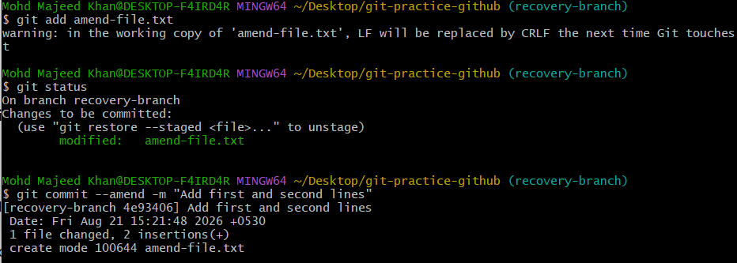
5: Cherry-pick a Commit: git cherry-pick <commit-ID> takes the changes from one specific commit and applies them to your current branch.
  - Take a specific commit from one branch and apply it to another branch.
The goal is to:
- Create a new branch.
- Make a commit on that branch.
- Get the specific commit ID.
- Switch to another branch.
- Use git cherry-pick <commit-ID> to apply that commit to the other branch.
- Verify that the commit is now present on the second branch.
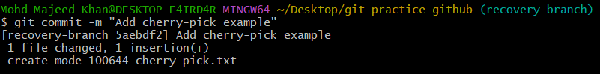
specific commit ID is: 5aebdf2
Cherry-pick the specific commit : git cherry-pick 5aebdf2(commit Id)

✅ Created cherry-pick.txt on recovery-branch
✅ Committed it:5aebdf2 Add cherry-pick example
✅ Switched to main
✅ Cherry-picked the specific commit: git cherry-pick 5aebdf2
✅ Git created the new commit on main:041cf7a Add cherry-pick example
✅ Verified with git log
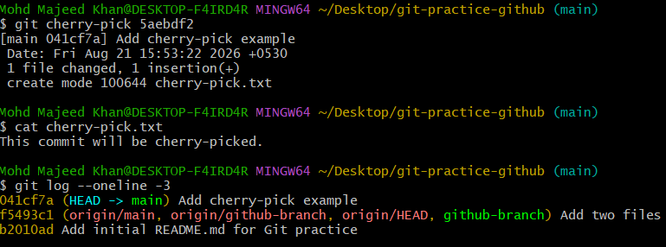
6: Interactive Rebase
Reorder and squash multiple commits into a single clean commit.
The goal is to:
- Create multiple commits on a branch.
- Use interactive rebase to look at those commits.
- Reorder the commits if needed.
- Squash multiple commits into one clean commit.
- Verify that the multiple commits have become a single commit.
- git rebase -i HEAD~3 ----- pick squash

Created three commits :
70c1991 Add first change
26a8ce3 Add second change
92abd8f Add third change

- Start interactive rebase : git rebase -i HEAD~3
- interactive rebase editor. 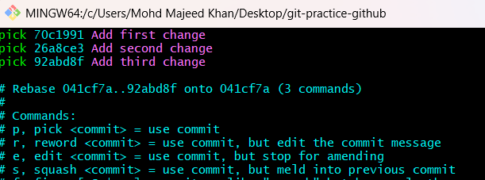
- Change pick to squash: Only change the words pick on the second and third lines to squash. Leave the first line as pick and save press enter Git will then open another editor for the combined commit message.
- Set the final commit message as the first line : Add all three changes (without #)

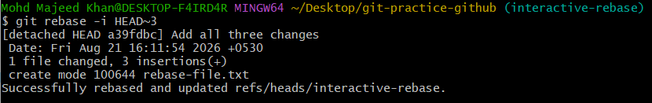

7: Tagging & Release
- Create a version tag (v1.0), push it to GitHub, then delete and restore it.

Goal
We will:
- Create a version tag called v1.0.
- Push the tag to GitHub.
- Delete the tag locally.
- Delete the tag from GitHub.
- Restore the tag from GitHub back to your local repository.
- Create the version tag v1.0
git tag v1.0 git tag output v1.0
- Push v1.0 to GitHub: git push origin v1.0
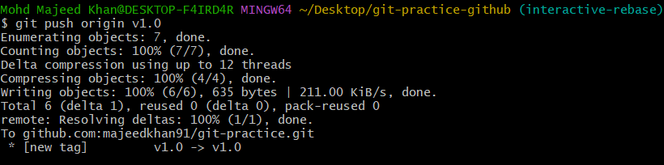
- Delete the local tag: git tag -d v1.0
- Delete v1.0 from GitHub : git push origin --delete v1.0

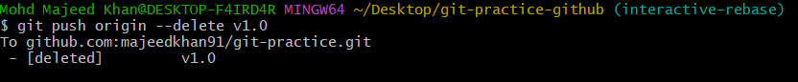

- Restore v1.0: git log --oneline -1
- Restore the tag
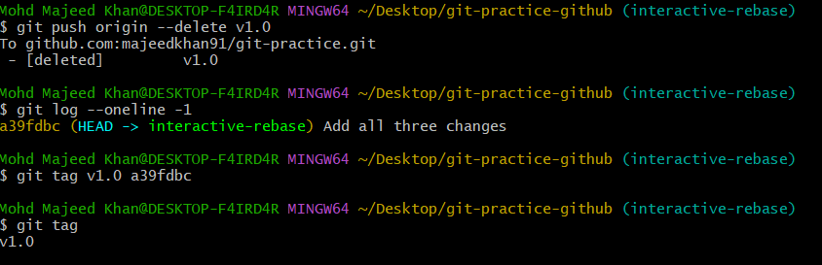

Push the restored tag back to GitHub: git push origin v1.0
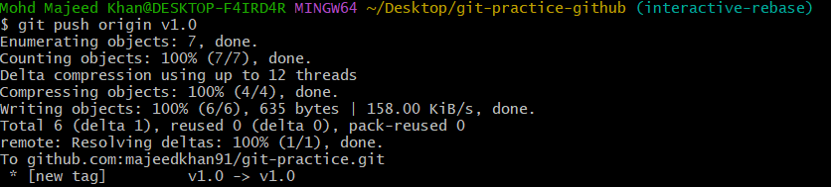

8: Clone with Sparse Checkout
- Clone only a subdirectory of a repo using sparse checkout.

The goal is to:
- Clone a GitHub repository.
- Enable sparse checkout.
- Select only one subdirectory from the repository.
- Verify that only that subdirectory appears in your working directory.

Create a subdirectory for the challenge
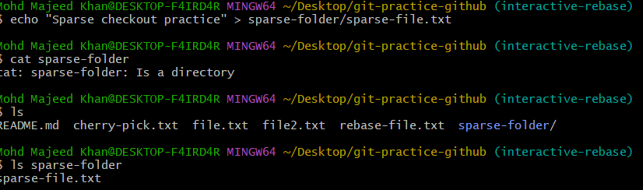

Add and commit the folder: git add sparse-folder

Push this commit to GitHub : git push origin interactive-rebase
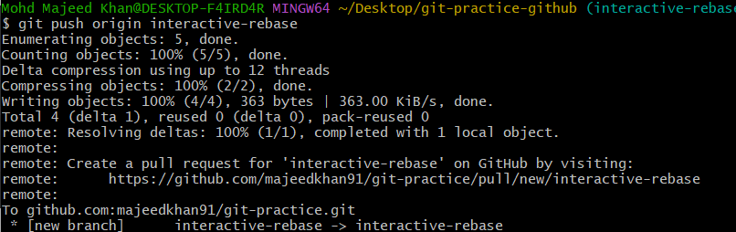
Clone only the required branch without checking out files:
git clone --no-checkout --branch interactive-rebase https://github.com/majeedkhan91/git-practice.git sparse-clone (This will create a new folder called sparse-clone, but it won't check out the files yet.)
Enable sparse checkout: git sparse-checkout init –cone git sparse-checkout set sparse-folder
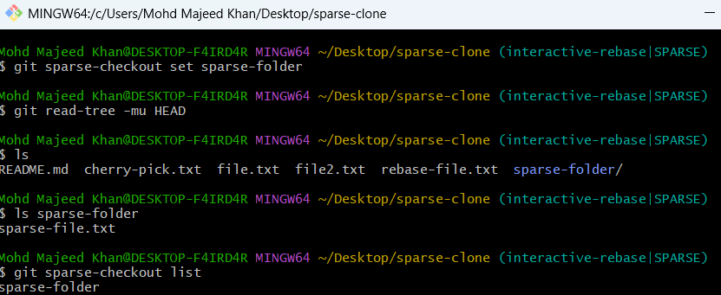
The key command to remember is: git sparse-checkout set sparse-folder

9: Reset vs Revert Challenge
- Demonstrate the difference between git reset --hard and git revert in a repo.

Goal
We will demonstrate the difference between:
- git reset --hard
- git revert

j
We'll do this in two parts:
Part A — reset --hard
- Create a practice branch.
- Make two commits.
- Use git reset --hard to go back one commit.
- Verify the second commit is gone from the branch history.
Part B — revert
- Create another commit.
- Use git revert on that commit.
- Verify the original commit remains in history and a new revert commit is created.

git checkout -b reset-revert-practice git branch
Create Commit 1 Create Commit 2
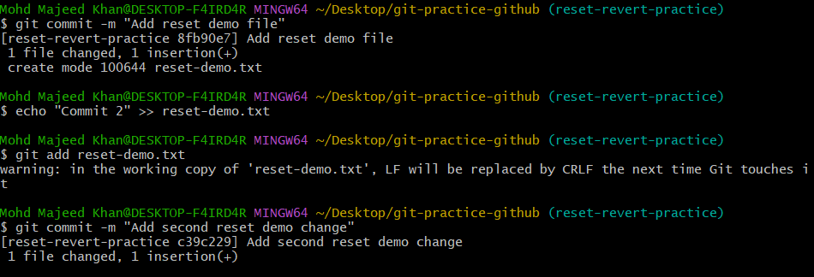
Check the history first: git log --oneline -2

Use git reset –hard - git reset --hard 8fb90e7
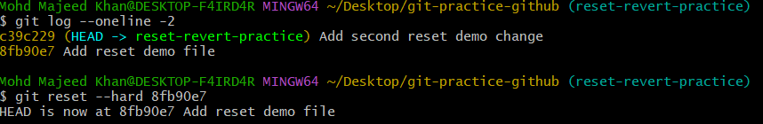
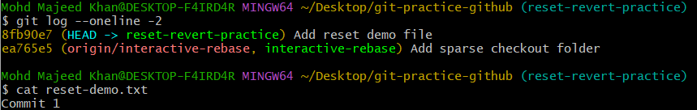
Part B — Demonstrate git revert
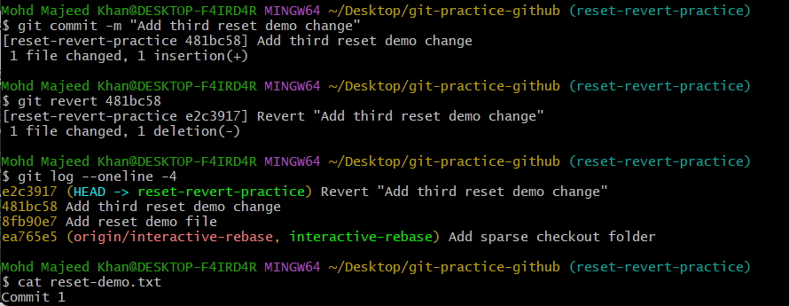
10: Detached HEAD Challenge
- Checkout a specific commit (detached HEAD state) and create a new branch from it.

Goal
We will:
- Find a specific commit.
- Checkout that commit.
- Enter Detached HEAD state.
- Verify that HEAD is detached.
- Create a new branch from that specific commit.
- Verify that we are back on the new branch.
Checkout the specific commit: git checkout 481bc58
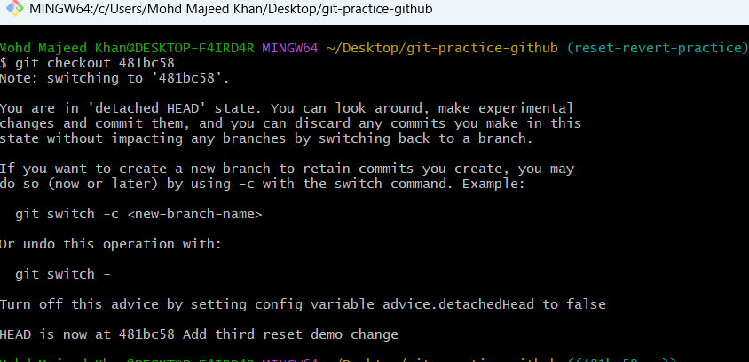
now in Detached HEAD state.
Create a new branch from this commit: git checkout -b detached-branch
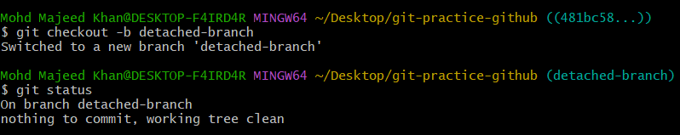

11: Git Hooks Challenge
- Configure apre-commit hook to reject commits without a message format (e.g., must start with JIRA-XXX).
We will:
- Configure a Git hook to check the commit message before committing.
- Set a required commit message format: JIRA-XXX.
- Reject commits that do not follow the required format.
- Allow commits that start with JIRA-XXX.
- Test the hook with both an invalid and a valid commit message.
- Verify that the valid commit is successfully created.
Go to the Git Hooks directory
cd .git/hooksls
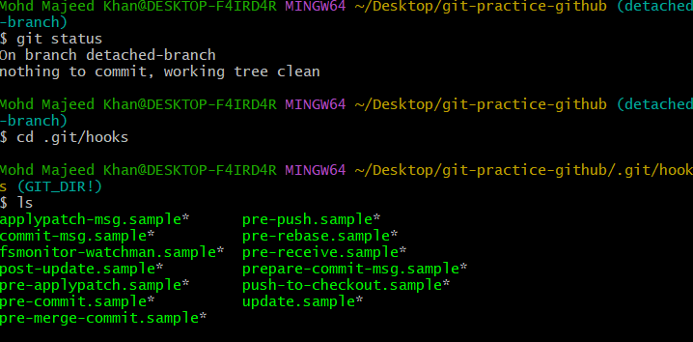
Create the commit-msg hook - Because our goal is to check the commit message format, we'll use the commit-msg hook.
Check the hook contents
chmod +x commit-msg
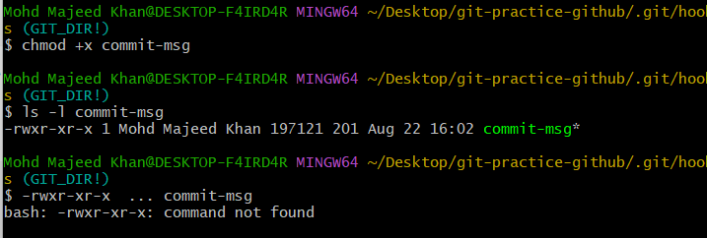
Test the hook with an invalid commit message :
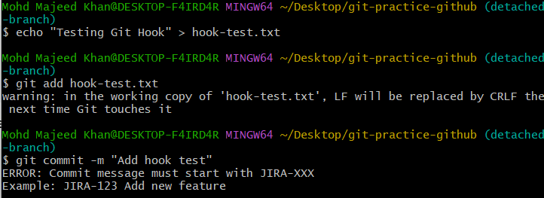
Test a valid commit message :
git commit -m "JIRA-123 Add hook test"
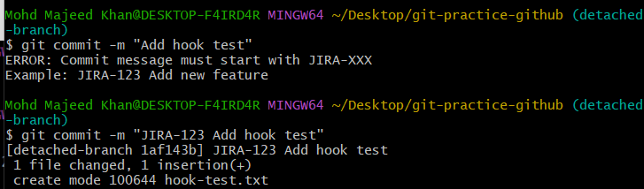
git log --oneline -1
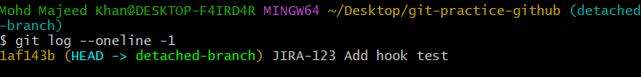
12.Squash Merge vs Rebase Merge
  - Show the difference between squash merge and rebase merge with evidence.
Goal
We will:
- Create a feature branch with multiple commits.
- Perform a Squash Merge and observe the Git history.
- Perform a Rebase Merge and observe the Git history.
- Compare the commit histories of both methods.
- Collect Git log evidence showing the difference.
Switch to main: git checkout main
Create a branch for Squash Merge: git checkout -b squash-feature
- Create multiple commits: Create the first change
echo "Squash merge - change 1" > squash-file.txt
git add squash-file.txt
git commit -m "Add squash change 1"

Create same change for 2nd and third same command chanfe 2 and 3then
Use git log --oneline --max-count=4

Commit the first Squash change

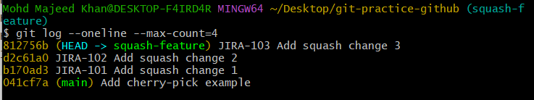

Perform Squash Merge: git checkout main

Now perform the squash merge:
git merge --squash squash-feature

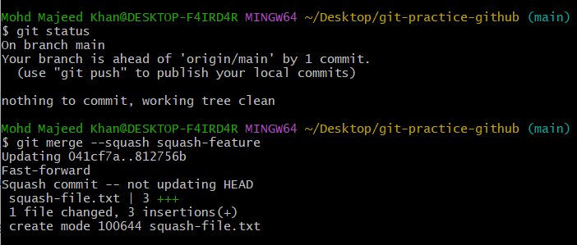
Create the Squash Commit
Verify the Squash Merge evidence
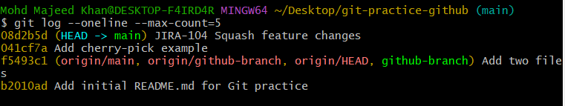
Start the Rebase Merge demonstration

Create 3 commits for Rebase Merge:
echo "Rebase merge - change 1" > rebase-file.txt
git add rebase-file.txt
git commit -m "JIRA-201 Add rebase change 1"

Show Rebase Merge evidence before merging
git log --oneline --max-count=5
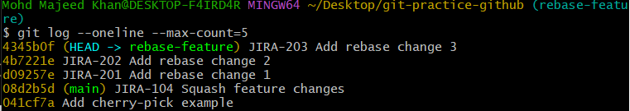
Rebase the feature branch onto main
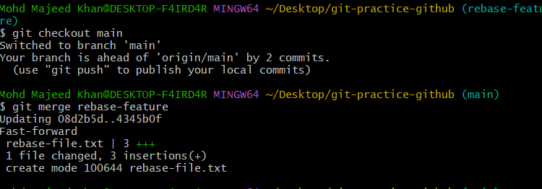
Get the final evidence
git log --oneline --max-count=7
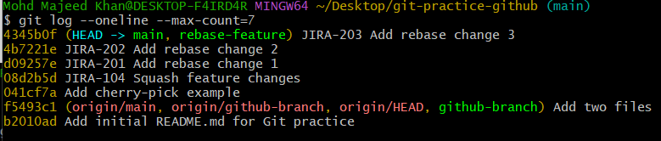

13: Fork & Pull Request Workflow
- Fork a repo, make a change, and submit a pull request to the original repo.

The goal is to learn how to contribute to someone else's GitHub repository without having direct permission to modify the original repository.
Original Repository ↓ Fork ↓ Your GitHub Repository ↓ Clone to your computer ↓ Make a change ↓ Commit ↓ Push to your fork ↓ Create Pull Request ↓ Original Repository

Clone your fork to Git Bash
git@github.com:majeedkhan91/Spoon-Knife.git

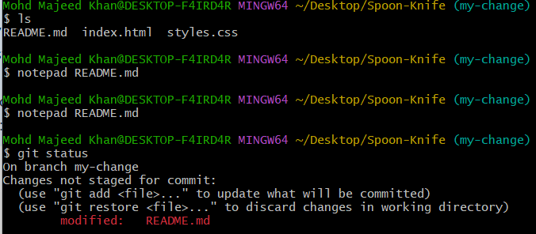
Add README.md : git add README.md
Commit: git commit -m "Update README for pull request practice"
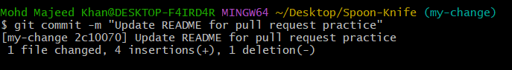
Push your branch to GitHub: git push -u origin my-change
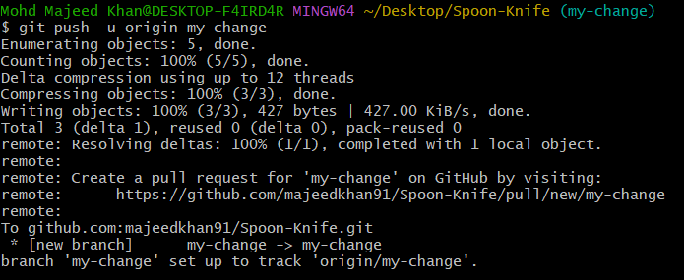
Create the Pull Request:
https://github.com/majeedkhan91/Spoon-Knife/pull/new/my-change

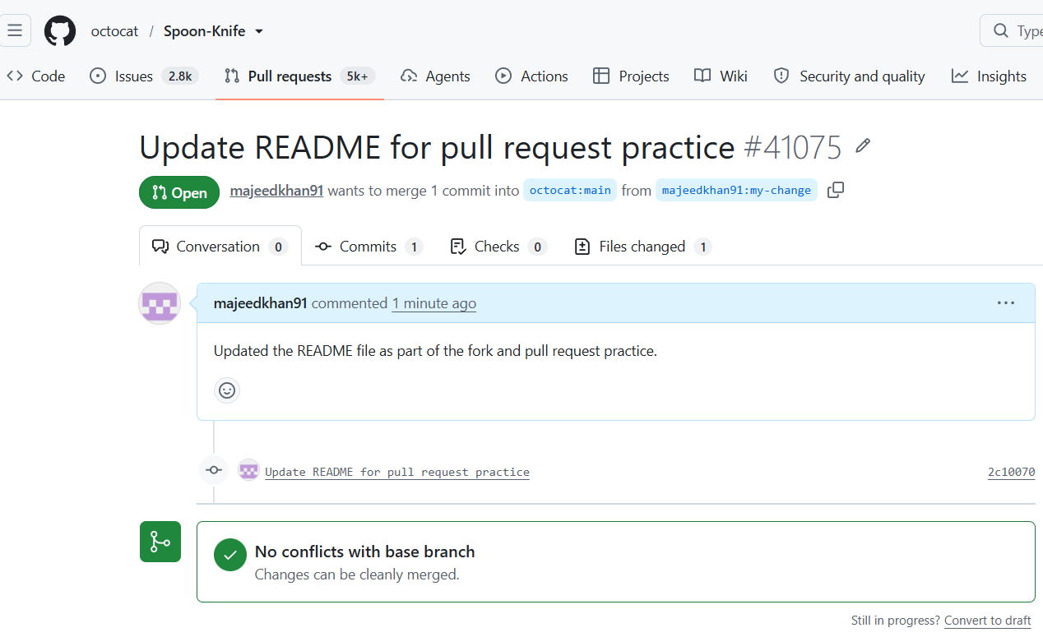

14: Recover Lost Commit
- Commit something, reset hard, and then recover it using git reflog.
Goal: We will intentionally "lose" a commit using git reset --hard, then recover that commit using git reflog.
Create a test file: echo "This commit will be recovered" > recover.txt cat recover.txt
Commit the file: git add recover.txt git commit -m "Add commit to recover" git log --oneline -3
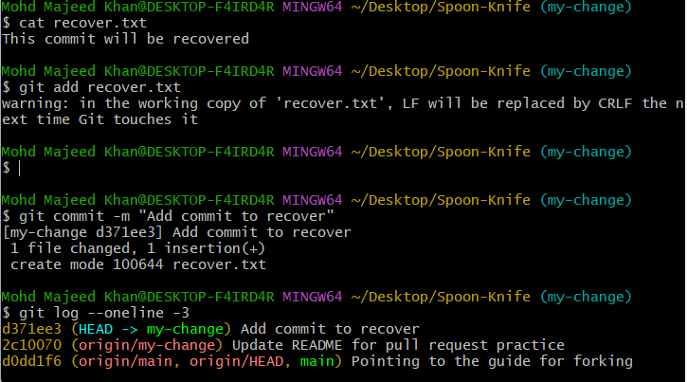
Reset hard: git reset --hard HEAD~1 git log --oneline -3
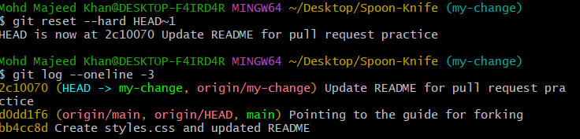
Check the reflog: git refloglook of commit d371ee3
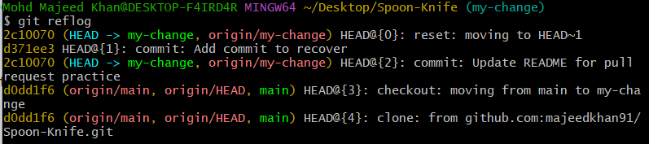
Recover the lost commit: git reset --hard d371ee3 git log --oneline -3ls

